Annual Employees Survey Analysis

**Introduction**

The annual survey on Employee Engagement and Satisfaction provides an organization with the opportunity to gain insight into the engagement of its employees. Focus scores are the percentage of respondents who agree or strongly agree with a specific questionnaire statement. The survey analysis outcome is a tool that can inform conversations with management, employees and human resource specialists about the underlying issues and challenges that exist in the workplace (Wake, & Green, 2019).

This report provides an in-depth analysis of the 2023 Recreation Unlimited results. It is designed to provide support with interpreting survey results and effectively using this information to improve employee engagement and satisfaction. The main variables of focus in this study include ‘Job satisfaction’, ‘Employee’s Engagement’, ’Turnover Intentions’, BARS and Sales.

**Methodology**

This study aimed to investigate the effects of Employee Engagement and Satisfaction among Recreation Unlimited employees. The study sample comprised 155 employees at a Recreation Unlimited organization. Data were collected through annual surveys to assess employees’ job attitudes. Each July, Recreation Unlimited invites employees to participate in the annual survey by sending out a link in a company-wide email. Descriptive statistics were used to present the characteristics of the sample to explore ‘Job satisfaction’, ‘Employee’s Engagement’, ’Turnover Intentions’. The correlation and multiple linear regression model were used to explore the relationship between sales (response) variable and the rest of the variables (predictors). Ethical considerations were considered throughout the study, and informed consent was obtained from all participants before participation. The Recreation’s Unlimited review board approved the study.

**Exploratory Data Analysis**

1. ***IDs for those employees who responded with Strongly Agree (5) to the following item: “During the next 12 months, I will probably look for a new job outside of Recreation Unlimited.” (TI2****).*

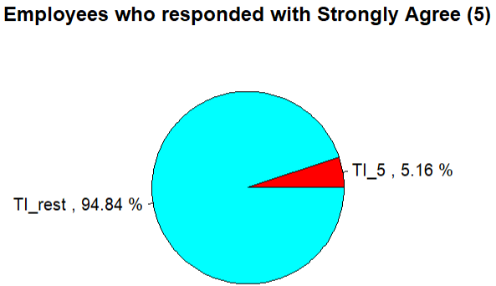

| EmployeeID | TI2 |
| --- | --- |
| EE1802 | 5 |
| EE1828 | 5 |
| EE1846 | 5 |
| EE1853 | 5 |
| EE1939 | 5 |
| EE1954 | 5 |
| EE1969 | 5 |
| EE1992 | 5 |

The results above illustrate the proportion of employees who responded with Strongly Agree (5) to the following item: “During the next 12 months, I will probably look for a new job outside of Recreation Unlimited. We can observe that about 5% of the total employees are likely to turn over the organization by the year 2014.

1. ***Internal consistency reliabilities (Cronbach’s alphas) of job satisfaction items***

Reliability analysis   
Call: alpha(x = SurveyData[, c("JS1", "JS2", "JS3", "JS4")])  
  
 raw_alpha std.alpha G6(smc) average_r S/N ase mean sd median_r  
 0.78 0.77 0.75 0.46 3.4 0.029 3.5 0.67 0.45  
  
 95% confidence boundaries   
 lower alpha upper  
Feldt 0.71 0.78 0.83  
Duhachek 0.72 0.78 0.83  
  
 Reliability if an item is dropped:  
 raw_alpha std.alpha G6(smc) average_r S/N alpha se var.r med.r  
JS1 0.69 0.68 0.65 0.41 2.1 0.044 0.0629 0.28  
JS2 0.84 0.84 0.78 0.64 5.3 0.022 0.0032 0.61  
JS3 0.66 0.66 0.61 0.39 1.9 0.047 0.0366 0.31  
JS4 0.67 0.66 0.60 0.40 2.0 0.047 0.0310 0.31  
  
 Item statistics   
 n raw.r std.r r.cor r.drop mean sd  
JS1 155 0.82 0.82 0.73 0.65 3.4 0.86  
JS2 155 0.58 0.60 0.36 0.32 3.7 0.82  
JS3 155 0.84 0.84 0.79 0.69 3.3 0.87  
JS4 155 0.84 0.83 0.79 0.68 3.4 0.92  
  
Non missing response frequency for each item  
 1 2 3 4 5 miss  
JS1 0.02 0.10 0.39 0.41 0.08 0  
JS2 0.00 0.06 0.36 0.42 0.15 0  
JS3 0.01 0.17 0.39 0.35 0.08 0  
JS4 0.01 0.15 0.35 0.36 0.12 0

The raw alpha (raw_alpha) based on job satisfaction (JS1, JS3,JS4) items falls under the questionable category in descriptors for Cronbach’s alpha while job satisfaction (JS2) exceeds the acceptable threshold of 0.70. - Therefore, we will retain all four items when computing the composite variable for job satisfaction because: Cronbach’s alpha for all four items is above 0.60; Removing an item would decrease Cronbach’s alpha, and. The content of all 3 items seems to fit within the conceptual definition of job satisfaction.

1. ***Internal consistency reliabilities (Cronbach’s alphas) of engagement items***

Reliability analysis   
Call: alpha(x = SurveyData[, c("Eng1", "Eng2", "Eng3")])  
  
 raw_alpha std.alpha G6(smc) average_r S/N ase mean sd median_r  
 0.87 0.87 0.82 0.69 6.7 0.018 3.7 0.74 0.7  
  
 95% confidence boundaries   
 lower alpha upper  
Feldt 0.83 0.87 0.90  
Duhachek 0.83 0.87 0.91  
  
 Reliability if an item is dropped:  
 raw_alpha std.alpha G6(smc) average_r S/N alpha se var.r med.r  
Eng1 0.82 0.82 0.70 0.70 4.7 0.028 NA 0.70  
Eng2 0.78 0.78 0.65 0.65 3.6 0.035 NA 0.65  
Eng3 0.84 0.84 0.73 0.73 5.4 0.025 NA 0.73  
  
 Item statistics   
 n raw.r std.r r.cor r.drop mean sd  
Eng1 155 0.88 0.89 0.80 0.75 3.7 0.79  
Eng2 155 0.91 0.91 0.85 0.79 3.6 0.85  
Eng3 155 0.88 0.88 0.77 0.72 3.7 0.85  
  
Non missing response frequency for each item  
 1 2 3 4 5 miss  
Eng1 0.00 0.05 0.37 0.43 0.16 0  
Eng2 0.01 0.08 0.31 0.46 0.14 0  
Eng3 0.00 0.07 0.35 0.40 0.18 0

The raw alpha (raw_alpha) based on all three engagement items exceeds the acceptable threshold of 0.70. - Therefore, we will retain all three items when computing the composite variable for engagement because: Cronbach’s alpha for all 3 items is above 0.70 (and thus acceptable); Removing an item would decrease Cronbach’s alpha, and. The content of all 3 items seems to fit within the conceptual definition of engagement.

***iv. Internal consistency reliabilities (Cronbach’s alphas) of turnover intentions items***

Reliability analysis   
Call: alpha(x = SurveyData[, c("TI1", "TI2", "TI3")])  
  
 raw_alpha std.alpha G6(smc) average_r S/N ase mean sd median_r  
 0.69 0.69 0.63 0.43 2.2 0.043 3 0.72 0.35  
  
 95% confidence boundaries   
 lower alpha upper  
Feldt 0.60 0.69 0.77  
Duhachek 0.61 0.69 0.78  
  
 Reliability if an item is dropped:  
 raw_alpha std.alpha G6(smc) average_r S/N alpha se var.r med.r  
TI1 0.51 0.52 0.35 0.35 1.06 0.078 NA 0.35  
TI2 0.48 0.48 0.32 0.32 0.92 0.084 NA 0.32  
TI3 0.76 0.76 0.61 0.61 3.18 0.038 NA 0.61  
  
 Item statistics   
 n raw.r std.r r.cor r.drop mean sd  
TI1 155 0.82 0.82 0.71 0.57 3.0 0.90  
TI2 155 0.84 0.83 0.73 0.59 2.9 0.96  
TI3 155 0.70 0.71 0.43 0.37 3.0 0.89  
  
Non missing response frequency for each item  
 1 2 3 4 5 miss  
TI1 0.05 0.21 0.48 0.21 0.05 0  
TI2 0.06 0.27 0.41 0.21 0.05 0  
TI3 0.03 0.26 0.35 0.34 0.01 0

The raw alpha (raw alpha) based on turnover intentions (TI1,TI2) items falls under Unacceptable category in descriptors for Cronbach’s alpha while turnover intentions (TI3) exceeds the acceptable threshold of 0.70. - Therefore, we will only retain TI3 item when computing the composite variable for turnover intentions because: its Cronbach’s alpha is above the acceptable threshold of 0.70; The content of TI3 item seems to fit within the conceptual definition of turnover intentions.

v. ***Measures of central tendency and dispersion for the three composite variables***

| Composite_Variable | min | Q1 | median | Q3 | max | mean | sd | n | missing |
| --- | --- | --- | --- | --- | --- | --- | --- | --- | --- |
| JS_Overall | 2.000000 | 3 | 3.500000 | 4.000000 | 5 | 3.464516 | 0.6726563 | 155 | 0 |
| Eng_Overall | 1.666667 | 3 | 3.666667 | 4.333333 | 5 | 3.679570 | 0.7403870 | 155 | 0 |
| TI_Overall | 1.000000 | 2 | 3.000000 | 4.000000 | 5 | 3.038710 | 0.8892129 | 155 | 0 |

Measures of central tendency were computed to summarize the data for the composite variables. Measures of dispersion were computed to understand the variability of scores for the composite variables. The results of the job satisfaction overall; N = 155, M=3.46, SD=0.67, Engagement overall; N = 155, M=3.68, SD=0.74, Turnover intention overall; N = 155, M=3.04, SD=0.88. When you look at the mean for:

* Job satisfaction overall, it appears that most employees neither disagreed nor agreed with the job satisfaction question statement. However, based on the small standard deviation, it looks like the employees’ response didn’t vary much.
* Engagement overall, it appears that most employees agreed with the job engagement statement. However, based on the small standard deviation, it looks like the employees’ response didn’t vary much.
* Turnover intention overall, it appears that most employees neither disagree nor agree with the turnover intention statement. However, based on the small standard deviation, it looks like the employees’ response didn’t vary much.

vi. ***Comparison between Recreation Unlimited’ s survey responses to employees’ responses from the 23 competitor organizations.***

| Survey question | Recreation's employees mean response | Benchmark's employees mean response |
| --- | --- | --- |
| Eng1 | 3.70 | 3.36 |
| Eng2 | 3.65 | 3.41 |
| Eng3 | 3.69 | 3.29 |
| JS1 | 3.43 | 3.71 |
| JS2 | 3.66 | 3.62 |
| JS3 | 3.32 | 3.48 |
| JS4 | 3.44 | 3.53 |
| TI1 | 2.99 | 2.71 |
| TI2 | 2.92 | 2.69 |
| TI3 | 3.04 | 2.88 |

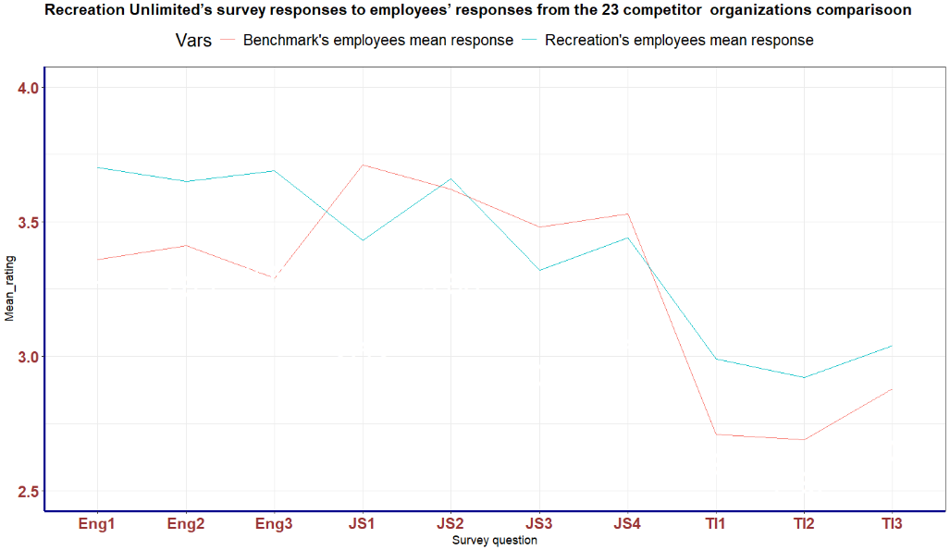

The table and line graph above provides us with information about the Recreation Unlimited employees’ mean responses versus employees’ responses across the 23 competitor organizations. From the results, we can see that:

* employees from Recreation Unlimited had higher ratings than the employees from other organizations. This appears that an employee in Recreation Unlimited feels energized at work and motivated to complete tasks, duties, and responsibilities.
* employees from Recreation Unlimited had higher ratings than the employees from other organizations. This appears that an employee in Recreation Unlimited feels energized at work and motivated to complete tasks, duties, and responsibilities.
* In general, employees from Recreation Unlimited had lower ratings than the employees from other organizations. This appears that an employee in Recreation Unlimited feels less satisfied with their job.
* employees from Recreation Unlimited had higher ratings than the employees from other organizations. This appears that an employee in Recreation Unlimited have little feeling in or thoughts of leaving the organization.

vii. **Correlation analysis**

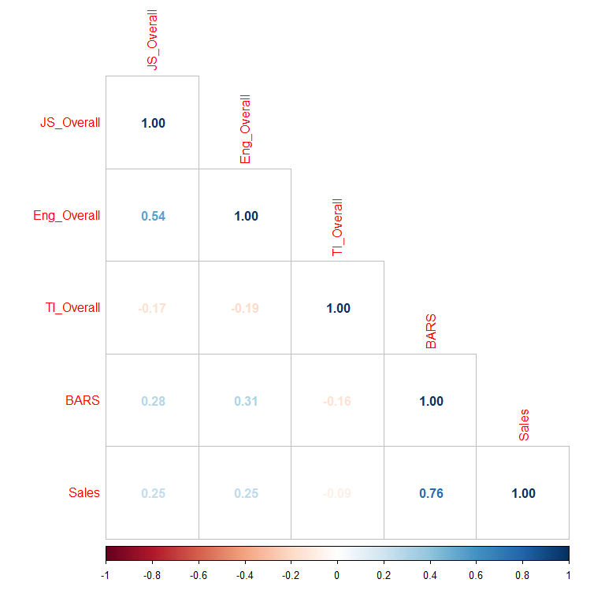

* The correlation between Job satisfaction composite variable (JS_Overall) & BARS scores (BARS) is 0.28. This indicates that the two variables have a positive and weak relationship.
* The correlation between Job satisfaction composite variable (JS_Overall) & sales revenue generated (Sales) is 0.25. This indicates that the two variables have a positive and weak relationship.
* The correlation between Engagement composite variable (Eng_Overall) & BARS scores (BARS) is 0.31. This indicates that the two variables have a positive and weak relationship.
* The correlation between Engagement composite variable (Eng_Overall) & sales revenue generated (Sales) is 0.25. This indicates that the two variables have a positive and weak relationship.
* The correlation between turnover intentions composite variable (TI_Overall) & BARS scores (BARS) is -0.16. This indicates that the two variables have a negative and weak relationship.
* The correlation between turnover intentions composite variable (Eng_Overall) & sales revenue generated (Sales) is -0.09. This indicates that the two variables have a negative and weak relationship.

**Multiple linear regression model**

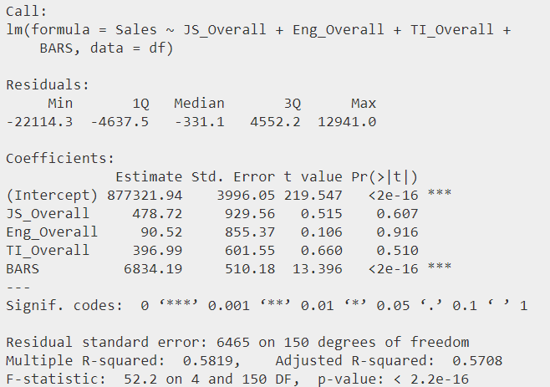

A multiple linear regression analysis was conducted to evaluate the extent to which sales could be predicted by composites and BARS variables. The results indicated that only the Bars variable is statistically significant to predict sales. A significant regression was found to be statistically significant (F (4,150) = 52.2, p<.0001).

The adjusted $R^{2}=$ 0.5708, indicates that all the explanatory variables together explained approximately 57.08%% of the variance in Recreation’s Unlimited sales. The regression equation was:

Sales = 877321.94 + 478.72(JS_overall) + 90.52(Eng_overall) + 396.99(TI_overall) + 6834.19(BARS).

**Make recommendations for the organization.**

The main aim of this report was to obtain insights that can inform conversations with management, employees and human resource specialists about the underlying issues and challenges that exist in the workplace. This study established that about 5% (8) of the employees in Recreation’s Unlimited could leave the organization by the end of the year 2023. It is therefore recommended that the organization engage these employees or start the process of replacement. Also, the analysis of employees’ job satisfaction shows that most of the employees are dissatisfied with their current job. It is recommended that that the organization’s management need to have an engagement with its employees to understand the underlying issues.

**Reference**

Wake, M., & Green, W. (2019). Relationship between employee engagement scores and service quality ratings: analysis of the National Health Service staff survey across 97 acute NHS Trusts in England and concurrent Care Quality Commission outcomes (2012–2016). BMJ open, 9(7), e026472.